Graph 1: Competitive Rankings of Super Smash Bros. Melee characters over time.

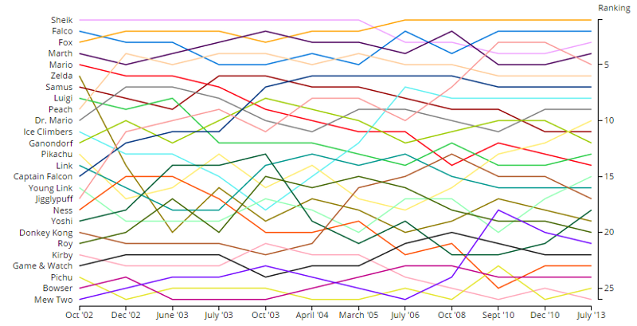

Interactive Version: <https://s3-us-west-2.amazonaws.com/forrestthewoods.staticweb/smash_brothers_charts/demo/part_1.html>

This interactive graph lets you highlight a character’s line and see how they progressed over time. I believe Tufte would like this graph; it, in order:

* Shows the data
* Lets us explore it for ourselves and think about what it means
* Does not distort it in any way
* Presents plenty of information in a relatively small space
* Makes 12 years of progression easy enough to follow
* Lets us easily compare the different parts of the data

It may be a bit cluttered and use too much ink – the interactive version is much easier to read -- but I believe this graph does what it sets out to do. It gives us a good visual of how the character order shuffled over time. The article it comes with (<https://blog.forrestthewoods.com/the-unbalanced-design-of-super-smash-brothers-3fbc9b346e15#.qw65p2yqz>) uses the graph to good effect when explaining its points.

Graph 2: Comparing AMDs and Intel CPUs using Geekbench Data

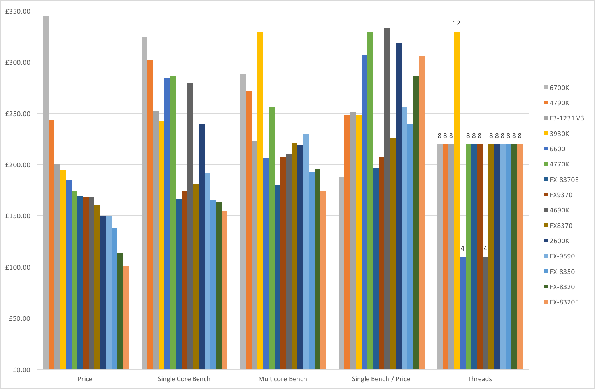

Link: <http://imgur.com/aWNWVxp>

I don’t like how this graph is laid out. I believe instead of grouping by each category (Price, Single-core bench, etc), it should have been grouped by processor and the colors should have indicated category. If I want to see how a single processor fares across the board I have to watch its color and scan across each category, which is a challenge.

However, this graph is multivariate and shows truthful data, so it at least follows Tufte’s principles. I hope Tufte would agree that this graph could have been laid out better for what it aimed to do.